Manipulation
Manipulation refers to the process of adjusting, cleaning, transforming raw data to make it organized, readable and well-structured for analysis.
In python, data manipulation has libraries like pandas, numpy, scipy etc.
- Pandas: Provides data structures like DataFrames to clean, filter, and manipulate data efficiently.
- NumPy: Supports large, multi-dimensional arrays and matrices, along with high level mathematical functions
- SciPy: Used for scientific computing, optimization and statistics.
Let us dive deeper into pandas.
Pandas
Pandas is the most popular open-source Python library for data manipulation and analysis. Built on the top of the NumPy, it introduces fast, flexible, and expressive data structures designed to work with relational or tabular data easily.
Installation of Pandas:
To get started we need to install pandas using pip:
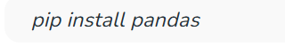
We import pandas from following Syntax:
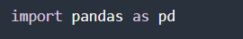
We also import numpy as a support for pandas:
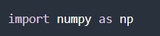

Basic Data Structures in pandas
Pandas provide two types of classes for handling data:
- Series: a one-dimensional labeled array holding data of any type such as integers, strings, Python objects etc.
- DataFrame : a two-dimensional data structure that holds data like a two-dimension array of a table with rows and columns.
Object Creation
Creating a series by passing a list of values.
Code Snippet:
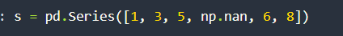
Output:
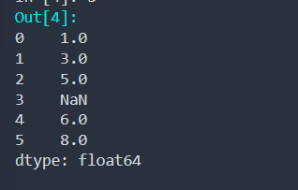
Here we have created a series data structure using pd.series method and pass a list of values to it.
And pandas by default create a range of index for each value in list.
- DataFrame
Creating a DataFrame by passing a dictionary of objects where the keys are the column labels and the values are the column values.
Code snippet:
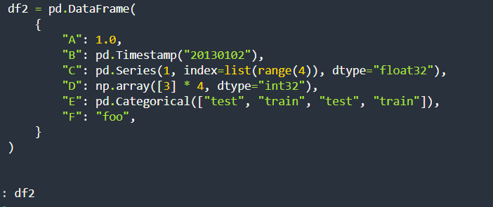
Output:
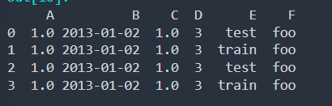
Data Visualization with Pandas
Pandas offers several features that make it a great choice for data visualization:
- Variety of Plot Types: Pandas supports various plot types including line plots, bar plots, histograms, box plots, and scatter plots.

- Customization: Users can customize plots by adding titles, labels, and styling enhancing the readability of the visualizations.

- Handling of Missing Data: Pandas efficiently handles missing data ensuring that visualizations accurately represent the dataset without errors.
- Integration with Matplotlib: Pandas integrates with Matplotlib that allow users to create a wide range of static, animated, and interactive plots.

Basic Plotting in Pandas
The plot method on series and DataFrame is just a simple wrapper around plt.plot():
Line Plot:
Line plot is used to visualize continuous data points over time.
Pandas .plot() creates line charts by default.
Code snippet:
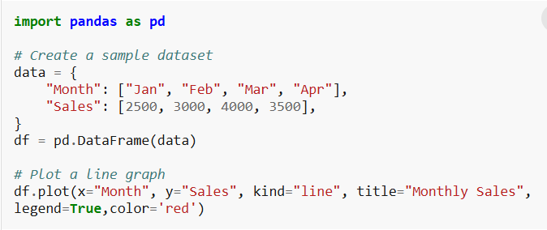
Description:
Creating a monthly sales dataset using dictionary and store it in data named variable.
pd.DataFrame(data) converts data into 2D DataFrame or in tabular structure and stored in variable named df.
df.plot() is used to plot line chart for DataFrame, x represent data on x axis, y represent data on y axis, kind for type of plot, title for understanding graph description , legend is used to explain what line style in charts represent, color to define color of line.

Output:
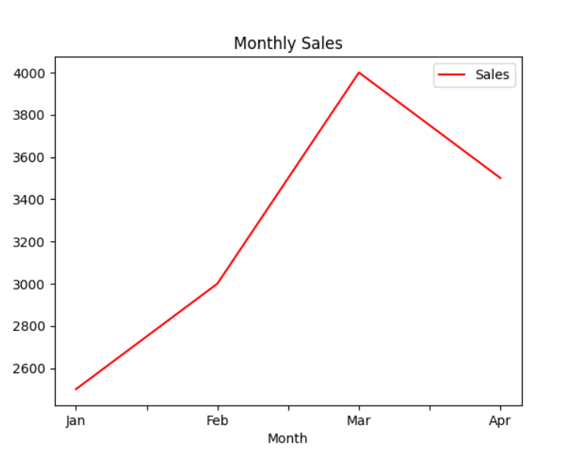
Bar Plot:
Rectangular bars are used in bar chart as the height represent the frequency of a particular element.
We can create bar plot by just passing the categorical variable in the X-axis and numerical value in the Y-axis.
Code Snippet:
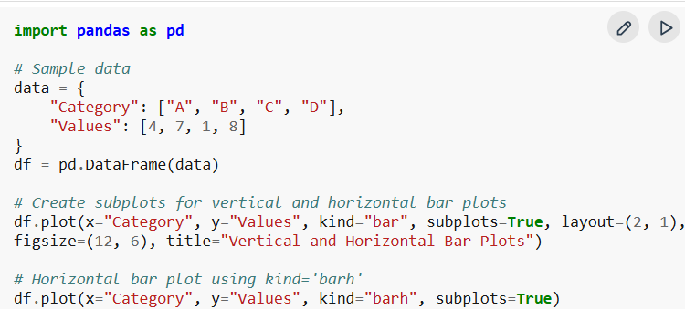

Output:
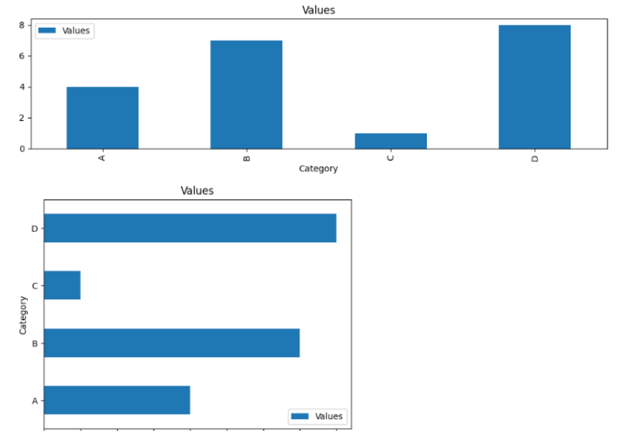
Description:
Created DataFrame named df.
Plot a bar graph by passing parameters for x axis, y axis, subplots is used to plot multiple plots and layout define size of the graph, figsize define height and width of the plot.
Histogram:
Histogram is a type of bar graph which is used to represent distribution of data in groups of bins. Using plot method of pandas we can create histogram as well.
Code Snippet:
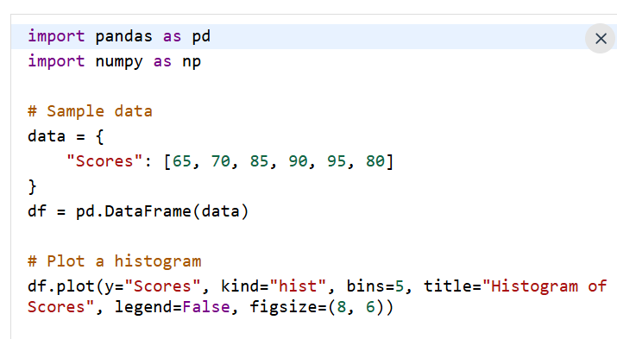
Description:
Created a sample data of score in form of dictionary and converted it to DataFrame using pd.DataFrame() method.
As histogram is single-variate graph so we only need to pass scores and histogram create frequency of data by its own on y axis, x axis represent range of data.

Output:
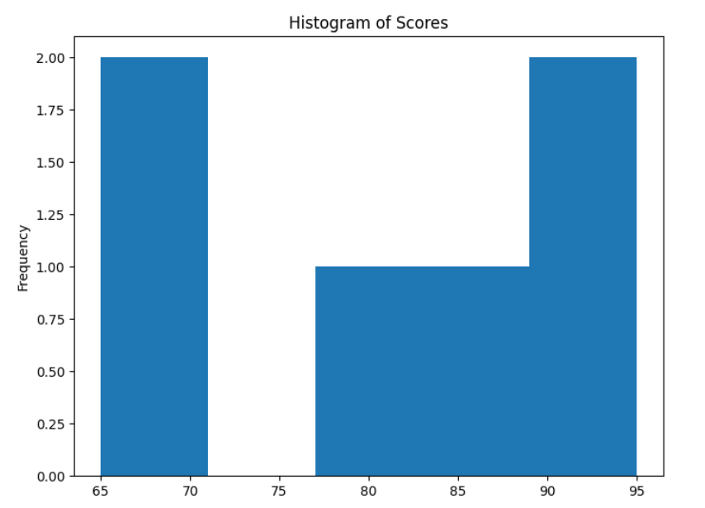
Box Plot:
We can create box plots to have a clear visualization and interpretation including outlier detection, interquartile ranges etc for each column in Pandas. By changing the kind to box, we can create box plots in just one line of code.

Code Snippet:
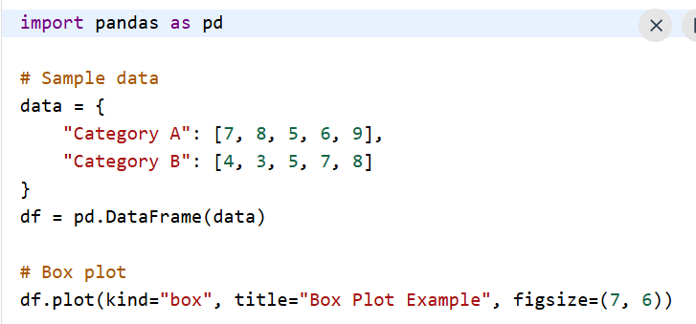
Output:
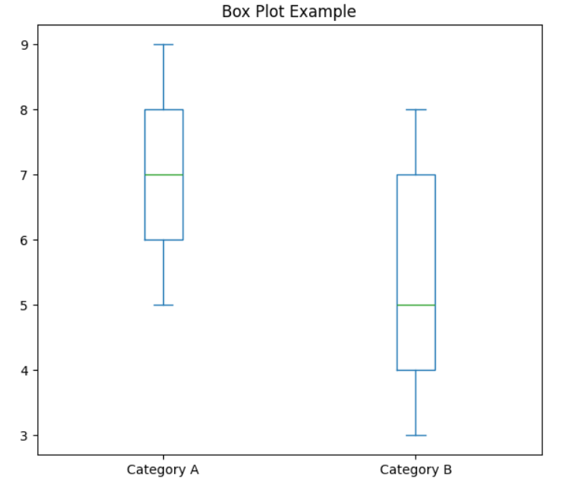
Description:
Created data with two category with different values and converted it into DataFrame. Using plot method and passing parameter as kind = box create boxplot.
Plot representing interquartile range of data, central line represent median value of each category and whiskers show min and max value within calculated range.

Pie Chart:
Pie chart is used to represent categorical data where each category is divided based on numerical percentage.
We can create pie charts using combination of plot method and set_index method. First we set the column as index and later on pass that index to the plot method and specify the category as pie.
Code Snippet:
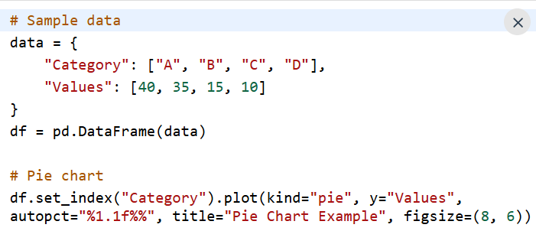
Description:
Created data with different category and values respectively and then converted it into DataFrame.
.set_index moves the category labels to the index so they automatically becomes the labels on chart.
.plot(kind="pie", y="Values")targets numerical column to build the pie section.
autopct calculates and display each slice percentage to one decimal place.

Output:
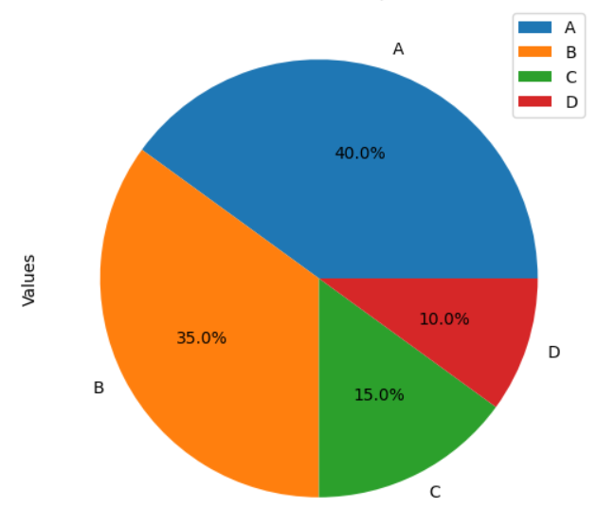

Seaborn
Seaborn is a Python library for creating statistical visualizations. It provides clean default styles and color palettes, making plots more attractive and easier to read. Built on top of Matplotlib and integrated with pandas data structures, Seaborn makes data visualization easier and more consistent.
- Seaborn emphasizes visualization as an essential part of data analysis.
- Its dataset-oriented APIs allow switching between different plot types for the same variables.
- Helps in understanding patterns, trends and relationships within the data.

Plots in Seaborn:
- Relational plots: used to understand the relation between two variables (e.g., lineplot, scatterplot)
- Categorical plots: deals with categorical variables and how they can be visualized (e.g., boxplot, violinplot, barplot)
- Distribution plots: show data distribution (e.g., histplot, kdeplot)
- Regression plots: show relationships with regression line (e.g., lmplot, regplot)
- Matrix plots: visualize matrices (e.g., heatmap)
- Multi-plot grids: plot multiple graphs together (e.g., FacetGrid)

Installation:
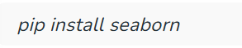
Basic Plots in Seaborn:
Lineplot
Lineplot is used to show the relationship between two continuous variables. It is commonly used for time-series or ordered data.
Code Snippet:
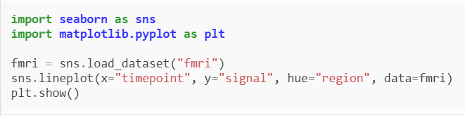
Output:
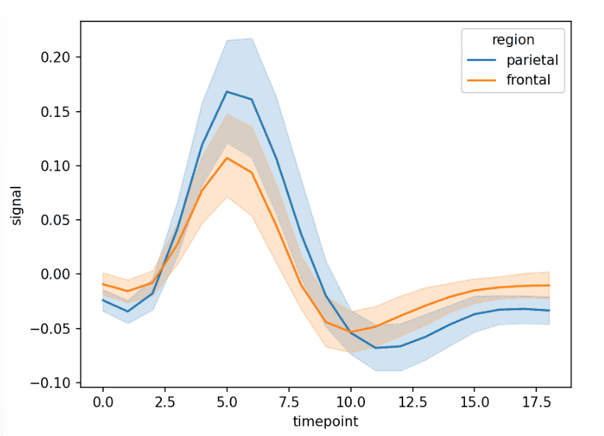
Description:
Line graph showing signal changes across timepoints for different regions.
x="timepoint" sets time on x-axis, y="signal" values plotted on y-axis and hue="region" separates lines by region
Scatter Plot:
Scatterplot is used to show the relationship between two numerical variables. It helps in identifying patterns or correlations.
Code Snippet:
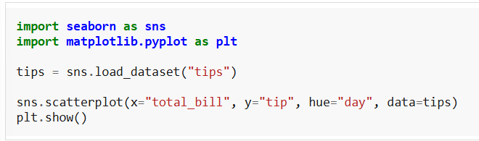
Output:
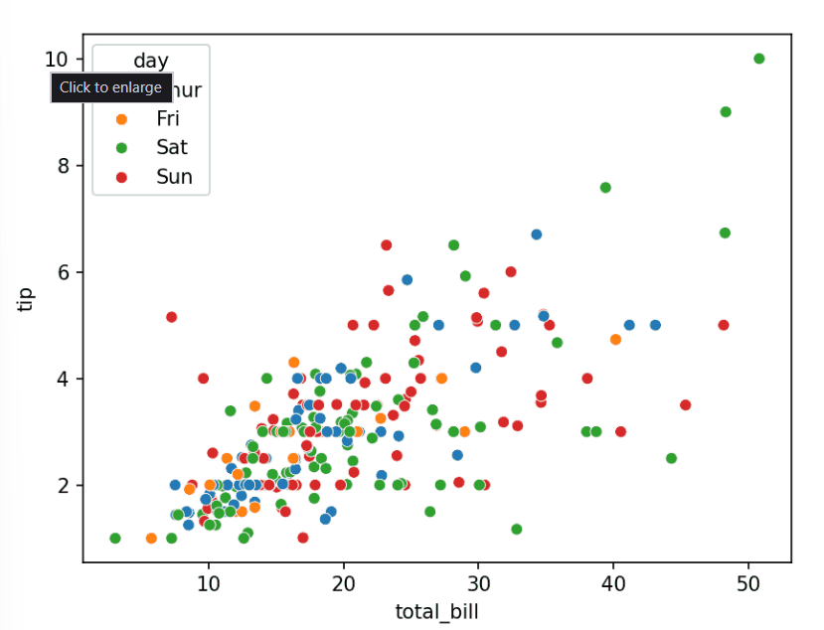
Description:
Scatter plot showing how tips vary with total bill across different days.
x, y numerical variables and hue="day" adds color grouping.
Bar Plot:
Barplot is used to compare numerical values across categories. It shows the average value with confidence intervals.
Code snippet:
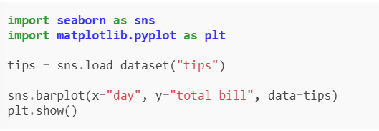
Description:
Bar chart showing average total bill for each day.
x="day" categories and y="total_bill" aggregated values (mean by default)
Output:

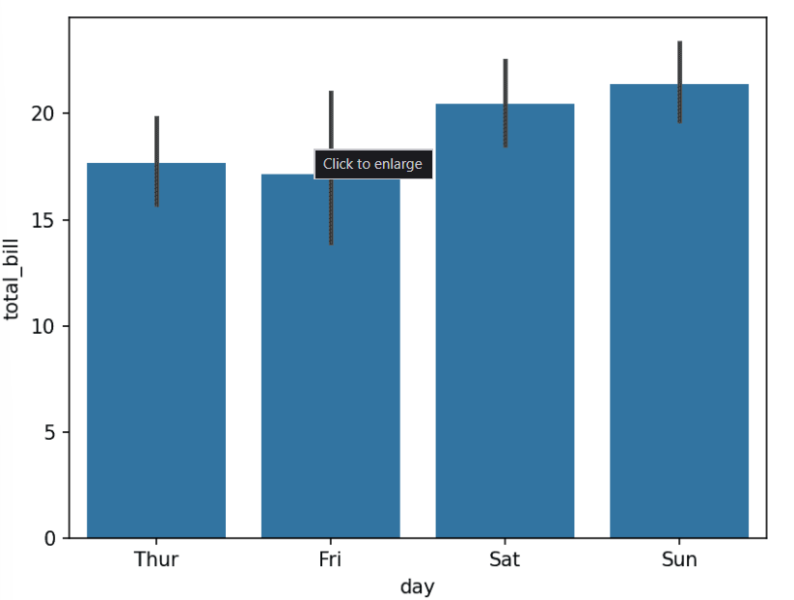
Box Plot:
Boxplot is used to show the distribution of data based on quartiles. It helps identify spread and outliers.
Code snippet:
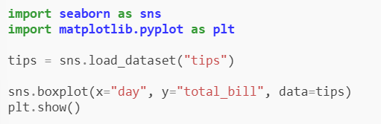
Output:
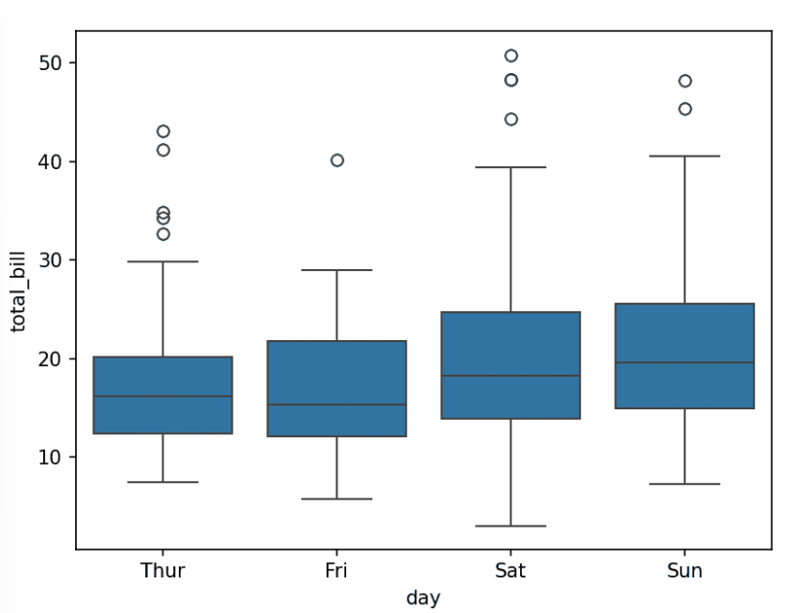
Description:
Box plot showing median, quartiles, and outliers for each day.

Histplot:
Histplot is used to visualize the distribution of a single numerical variable.

Code Snippet:
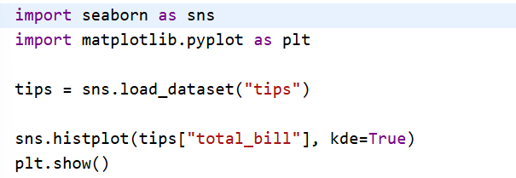
Output:
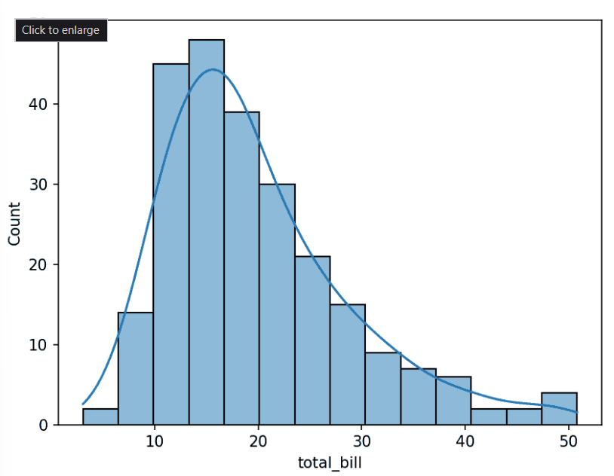
Description:
Histogram with a smooth density curve.
kde=True adds density curve
Heatmap:
Heatmap is used to visualize matrix-like data using colors. It is commonly used for correlation matrices.
Code Snippet:
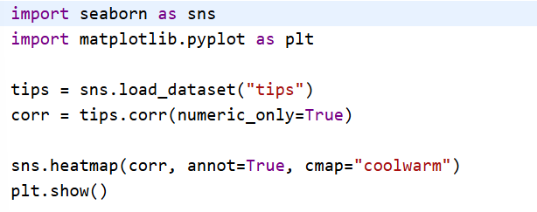
Description:
Color-coded matrix showing correlations between variables.
annot=True displays values and cmap controls color scheme

Output:
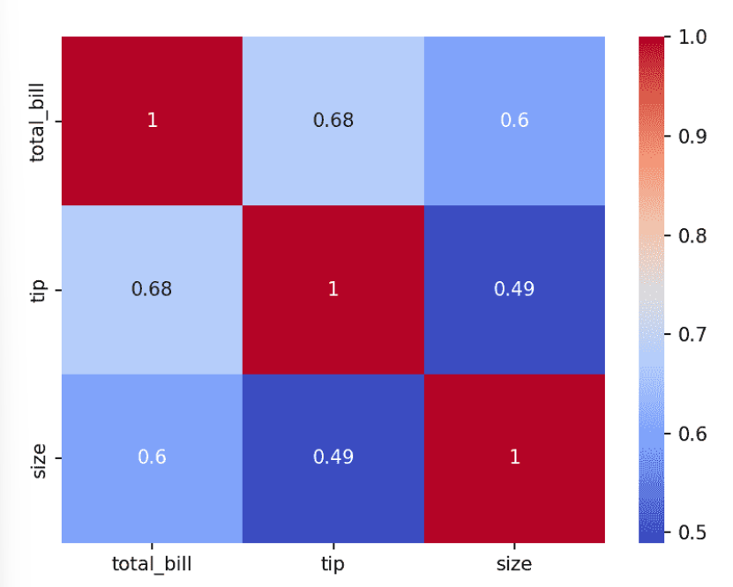
Pairplot:
Pairplot is used to plot pairwise relationships between multiple numerical variables.
Code Snippet:
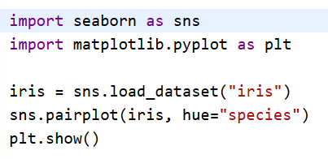
Output:
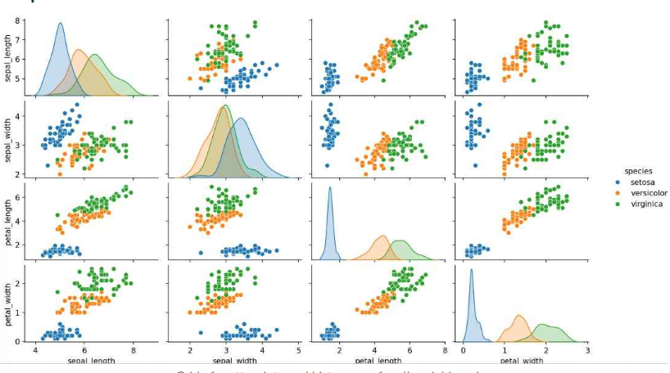

Description:
Grid of scatterplots and histograms for all variable pairs.
hue adds category distinction.
Comparison between Pandas and Seaborn

Pandas
- Basic Visualization: Pandas provides simple and quick plotting capabilities using the .plot() method. It is mainly used for visualizing data during analysis and exploration.
- Built on Matplotlib: Pandas uses Matplotlib as its default visualization backend, making it easy to generate basic charts without writing extensive code.
- Data Exploration: It is ideal for creating quick line plots, bar charts, histograms, box plots, scatter plots, and area charts to understand datasets.
- Ease of Use: Users can create visualizations directly from DataFrames and Series with minimal syntax, making it suitable for beginners.
- Customization: Although Pandas supports customization, advanced styling and formatting options are limited compared to specialized visualization libraries.
- Integration: Since Pandas is primarily a data manipulation library, its visualization functions are tightly integrated with data cleaning, filtering, and preprocessing tasks.

Advantages of Pandas Visualization:
- Quick and simple plotting using DataFrames.
- No need for extensive plotting code.
- Best for exploratory data analysis (EDA).
- Seamless integration with data manipulation operations.

Seaborn
- Advanced Visualization: Seaborn is a statistical data visualization library built on top of Matplotlib. It is specifically designed to create attractive and informative graphics.
- Statistical Plots: Seaborn provides specialized plots such as heatmaps, pair plots, violin plots, swarm plots, box plots, count plots, regression plots, and distribution plots.
- Built-in Themes: It offers attractive default themes, color palettes, and styling options, producing publication-quality visualizations with minimal effort.
- Relationship Analysis: Seaborn makes it easy to visualize relationships between multiple variables and discover patterns, trends, and correlations in data.
- High Customization: It supports advanced customization of colors, legends, annotations, and plot layouts while maintaining a clean and professional appearance.
- Pandas Integration: Seaborn works directly with Pandas DataFrames, allowing users to create complex statistical visualizations without extensive preprocessing.

Advantages of Seaborn Visualization:
- Beautiful and professional-looking graphs.
- Rich collection of statistical plots.
- Excellent support for multivariate data visualization.
- Simple syntax for complex visualizations.
- Built-in themes and color palettes improve readability.

